 

## REAL TIME IMAGE SIZE MEASUREMENT

### A PROJECT REPORT

*Submitted by*

DINESH S (927621BAD011)

KAVIN K V (927621BAD021) SHARAN ADHITHYA S (927621BAD047)

*In partial fulfilment of the award of the degree of*

## BACHELOR OF TECHNOLOGY

In

### ARTIFICIAL INTELLIGENCE AND DATA SCIENCE

#### M.KUMARASAMY COLLEGE OF ENGINEERING, KARUR

**ANNA UNIVERSITY: CHENNAI 600 025**

NOV 2023

# M.KUMARASAMY COLLEGE OF ENGINEERING

**(Autonomous Institution affiliated to Anna University, Chennai)**

## BONAFIDE CERTIFICATE

Certified that this project report **“REAL TIME OBJECT SIZE MEASUREMENT”** is the Bonafide work of **“DINESH S (927621BAD011),**

**KAVIN K V (927621BAD021), SHARAN ADHITHYA S (927621BAD047)”** who carried out the minor project work during the academic year 2023-2024 under our supervision. Certified further, that to the best of our knowledge the work reported herein does not form part of any other minor project report or dissertation on the basis of which a degree or award was conferred on an earlier occasion on this or any other candidate.

**SIGNATURE**  **SIGNATURE**

Dr. R. RAJA GURU ,M.Tech.,Ph.D., Mr. R. VIJAYAGANTH ,M.E.,

**ASSOCIATE PROFESSOR AND HEAD** **SUPERVISOR**

Department of Artificial Intelligence,Assistant Professor/ AI

M.Kumarasamy College of Engineering,  Department of Artificial Intelligence,

Thalavapalayam, M.Kumarasamy College of Engineering, Karur-639113. Thalavapalayam,

Karur-639113.

.

**TABLE OF CONTENTS**

|  |  |  |
| --- | --- | --- |
| **CHAPTER NO** | **TITLE** | **PAGE NO** |
|  | **ABSTRACT** | **4** |
|  | **LIST OF FIGURES** | **5** |
|  |  |  |
|  | **ACRONYMS/LIST OF ABBREVIATIONS** | **6** |
| **1** | **INTRODUCTION** | **7** |
|  | 1.1 BACKGROUND | **8** |
|  | 1.2 PROBLEM STATEMENT | **9** |
|  | 1.3 OBJECTIVES | **10** |
| **2** | **LITERATURE REVIEW** | **11** |
| **3** | **FEASIBILITY STUDY** | **15** |
| **4** | **PROJECT METHODOLOGY** | **19** |
|  | 4.1 DESCRIPTION OF THE WORKING FLOW OF PROPOSED SYSTEM.  4.2 USER WORKING WITH PROPOSAL SYSTEM | **20**  **21** |
| **5** | **RESULTS AND DISCUSSION** | **22** |
| **6** | **CONCLUSION** | **27** |
| **7** | **REFERENCES** | **29** |

# ABSTRACT

### Real-time object size measurement using OpenCV involves using computer vision techniques to estimate the size of objects in a video stream or image. This can be done by first loading an image of an object, converting it to grayscale, and applying a threshold to separate the object from the background. The problem statement for a real time object size measurement project is to develop a system that can accurately and efficiently measure the dimensions of objects in real time. This can be a challenging task, as it requires the system to be able to, Identify and track the object in the image or video stream. Estimate the distance between the object and the camera. Use this information to calculate the object's dimensions. Real-time object size measurement is a challenging problem in computer vision. It is required in many applications, such as self-driving cars, robotics, and manufacturing. The goal of this project is to develop a real-time object size measurement system using computer vision. The proposed system will use a camera to capture images of objects. The images will then be processed using computer vision algorithms to identify and segment the objects. Computer vision provides support to computers to observe and understand. Computer vision helps the computer in understanding a 3D surrounding from a 2D image and trains the computer to perform different functions. It also helps in Human Computer Interaction effectively because it is able to differentiate the objects with surroundings and provide us with the key information. The algorithm uses a convolutional neural network (CNN) to extract features from images, which are then used to generate object proposals.

#### LIST OF FIGURES:

|  |  |  |
| --- | --- | --- |
| **Figure No** | **Figure Name** | **Page No** |
| **4.1** | **DESCRIPTION OF THE WORKING FLOW OF PROPOSAL SYSTEM:** | **20** |
| **4.2** | **USER WORKING WITH PROPOSAL SYSTEM:** | **21** |
| **5.1** | **IMAGE ACQUISITION:** | **23** |
| **5.2** | **OBJECT DETECTION & SEGMENTATION** | **24** |
| **5.3** | **OUTPUT OF OBJECT SIZE MEASURED** | **25** |
| **5.4** | **OBJECT SIZE MEASUREMENT CODE SCREENSHOT** | **26** |

**ACRONYMS/LIST OF ABBREVIATIONS:**

**S.No. Acronym Abbreviations**

**1. OpenCV - OPEN SOURCE COMPUTER VISION**

**LIBRARY**

**2. CNN - CONVOLUTIONAL NEURAL NETWORK**

**3. CVPR - COMPUTER VISION & PATERN**

**RECOGNITION**

# CHAPTER-1

**INTRODUCTION**

#### BACKGROUND:

This can be done by first loading an image of an object, converting it to grayscale, and applying a threshold to separate the object from the background. The problem statement for a real time object size measurement project is to develop a system that can accurately and efficiently measure the dimensions of objects in real time. This can be a challenging task, as it requires the system to be able to, Identify and track the object in the image or video stream. Estimate the distance between the object and the camera. Background work in a real-time object size measurement project involves various essential steps and considerations before you begin the practical implementation. The right hardware components for your project, such as cameras or imaging devices, lighting systems, computing hardware, and any specialized sensors or equipment needed for accurate measurements. Determine the type of imaging technology you will use, such as 2D or 3D imaging, depending on the complexity and accuracy requirements of your size measurements. Take into account the environmental conditions in which your system will operate, such as lighting conditions, temperature, humidity, and potential obstacles that may affect image quality and object detection. Choose the appropriate software tools, libraries, and algorithms for image acquisition, preprocessing, object detection, and size measurement. Libraries like OpenCV and machine learning frameworks like TensorFlow or PyTorch may be useful.

#### PROBLEM STATEMENT:

The object detection system detects whether things are present or absent in particular scenes and from particular camera angles. The diverse object detection domains are based on varied goals and are categorized using concrete and abstract terms. The various models that are either expressly or implicitly employed for object detection. The components may or may not vary depending on the different techniques, selecting an item based on a hypothesis and selecting an item based on matching. The most effective processing technique is object detection. The problem statement for a real time object size measurement project is to develop a system that can accurately and efficiently measure the dimensions of objects in real time. This can be a challenging task, as it requires the system to be able to, Identify and track the object in the image or video stream. Estimate the distance between the object and the camera.

#### OBJECTIVES:

Real-time object size measurement is a challenging problem in computer vision. It is required in many applications, such as self-driving cars, robotics, and manufacturing. The goal of this project is to develop a real-time object size measurement system using computer vision. The proposed system will use a camera to capture images of objects. The images will then be processed using computer vision algorithms to identify and segment the objects. Ensure that manufactured products meet the required specifications by accurately measuring their dimensions in real-time. This can help identify defects or variations in size that could lead to product quality issues. Real-time object size measurement can help optimize manufacturing processes by providing immediate feedback on product dimensions. The measurements can be utilized in various applications, such as automatic parking solutions, self-driving automobiles and e-commerce platforms to determine the size of the object. This allows for adjustments and corrections to be made quickly, reducing waste and improving efficiency.

# CHAPTER-2 LITERATURE REVIEW

## Object Detection and Tracking by Using OpenCV and Deep Learning, (2018).

Real-Time Object Detection and Tracking Using Deep Learning and OpenCV is a research paper published in the proceedings of the 2018 International Conference on Inventive Research in Computing Applications. The paper proposes a real-time object detection and tracking system using deep learning and OpenCV. The library is intended for use in real-time applications such as robotics, surveillance, and image and video processing. The paper describes the key features of OpenCV, including its image and video processing functions, feature detection and extraction algorithms, and machine learning capabilities.

## Unified, real-time object detection, (2015).

Object detection and tracking using OpenCV and deep learning is a common and effective approach for various computer vision applications. OpenCV is an open-source computer vision library that provides a wide range of tools and functions for image and video processing. Deep learning models, such as Convolutional Neural Networks (CNNs), have significantly improved object detection and tracking tasks. A method for texture classification that can be used for object detection. The method uses local binary patterns to extract features from images at multiple scales and orientations, which are then used to train a classifier. The paper presents experimental results that show the effectiveness of the proposed method.

## Fast R-CNN, In Proceedings of the IEEE international conference on computer vision, (2015).

Fast R-CNN is a deep learning-based object detection framework introduced in the paper "Fast R-CNN" by Ross Girshick. The paper was presented at the IEEE International Conference on Computer Vision (ICCV) in 2015. Fast R-CNN builds upon the earlier. Region-based Convolutional Neural Network (R-CNN) and Over Feat

approaches, and it significantly improved the efficiency and accuracy of object detection. A comparative studyof object detection algorithms, including Haar cascades, Histogram of Oriented Gradients(HOG), and deep learning-basedmethods such as YOLO, Faster R-CNN, and SSD.

## (YOLO) You only look once: Unified, real-time object detection, (2015).

You Only Look Once (YOLO) Unified, Real-Time Object Detection, which presents an object detection algorithm that can detect objects in real-time with high accuracy. The algorithm uses a single neural network to predict object classes and bounding boxes directly from input images, eliminating the need for region proposals. You Only Look Once" paper, authored by Joseph Redmon and Santosh Divvala, was presented at the IEEE Conference on Computer Vision and Pattern Recognition (CVPR) in 2016. YOLO is a groundbreaking real- time object detection system that has had a substantial impact on the field of computer vision

## Application of object detection and tracking techniques for unmanned aerial vehicles, (2015).

Object detection and tracking techniques are increasingly being applied to unmanned aerial vehicles (UAVs) in various fields to enhance their capabilities and enable a wide range of applications. UAVs equipped with object detection and tracking capabilities can be used for surveillance and security purposes. They can detect and track intruders, monitor critical infrastructure, and provide real-time alerts in case of suspicious activities. UAVs equipped with object detection can monitor crop health, detect pests or diseases, and track the growth of crops. This information can help farmers make informed decisions about irrigation and pesticide use. UAVs are employed for inspecting infrastructure like bridges, power lines, and pipelines. Object detection and tracking can identify defects or anomalies in structures, facilitating maintenance and repairs.

* + 1. **Comparative Study of Object Detection Algorithms, (2017).**

A comparative study of object detection algorithms is a valuable project that aims to assess and compare the performance of various object detection methods. This type of project can help researchers and developers make informed decisions when choosing an algorithm for a specific application. Gather a diverse and representative dataset for your evaluation. This dataset should include various object classes, lighting conditions, and object orientations. Annotate the dataset with ground-truth bounding boxes. Define the evaluation metrics you will use to compare the algorithms. Common metrics include precision, recall, F1-score, mean average precision (mAP), inference time, and hardware resource usage. Set up a controlled experimental environment, ensuring that the algorithms have equal access to the same hardware and software resources. Make sure the dataset is divided into training and testing sets.

# CHAPTER-3

**FEASIBILITY STUDY**

#### IMAGE ACQUISITION MODULE:

Image acquisition is a crucial step in real-time object size measurement projects. It involves capturing video or still images of the objects of interest using a camera or other imaging device. The quality and accuracy of the acquired images significantly impact overall performance of the object size measurement system. The goal of image acquisition is to capture high-quality images of the object to be measured, at a frame rate that is sufficient to support real-time processing. The camera captures video or still images of the objects of interest. The choice of camera depends on the application's requirements, object size, and environmental conditions. Preprocessing techniques enhance the quality of acquired images and prepare them for subsequent object detection and size measurement algorithms. These techniques may include noise reduction, contrast enhancement, and image filtering.

#### OBJECT DETECTION MODULE:

Object detection is a critical component of real-time object size measurement projects. It involves identifying and locating objects of interest within the acquired images or video frames. Accurate object detection is essential for isolating the objects whose sizes need to be measured and for providing bounding boxes or other spatial information that is crucial for size estimation. Object detection enables the system to identify and locate objects of interest within a camera's field of view. Object detection identifies and locates objects of interest within the acquired images or video frames. Accurate object detection is essential for isolating the objects whose sizes need to be measured and for providing bounding boxes or other spatial information that is crucial for size estimation.

#### OBJECT SEGMENTATION MODULE:

Object segmentation is an important step, as it helps isolate and identify the objects of interest within an image or video frame. It involves partitioning an image into distinct regions or segments, each corresponding to a specific object or background element. Accurate object segmentation provides precise spatial information about objects, enabling more accurate size measurements. Object segmentation partitions an image into distinct regions or segments, each corresponding to a specific object or background element. Accurate object segmentation provides precise spatial information about objects, enabling more accurate size measurements. Size estimation algorithms determine the size or dimensions of the objects of interest based on the information provided by object detection and segmentation. Various techniques can be used for size estimation, including using bounding boxes, reference objects.

#### OBJECT MEASUREMENT MODULE:

Object measurement is the final step in real-time object size measurement projects. It involves determining the dimensions of the segmented objects, typically expressed as length, width, and height. Accurate object measurement requires precise object segmentation and knowledge of the camera's calibration parameters. Measuring object size in a real-time involves accurately determining the physical dimensions of objects based on the information gathered from image or video data. Size estimation algorithms determine the size or dimensions of the objects of interest based on the information provided by object detection and segmentation. Various techniques can be used for size estimation, including using bounding boxes, reference objects, or 3D reconstruction methods. Visualization techniques present the size measurements and other relevant information to the user in a clear and understandable manner. This may involve overlaying size information on the images or video frames, generating reports, or creating interactive visualizations.

**OPTIMIZATION AND DISPLAY MODULE:**

Algorithm Optimization: Fine-tunes object detection and size measurement algorithms for efficiency. Graphical User Interface (GUI): Displays real-time object size measurements and other relevant information. Employing data compression techniques to reduce the storage requirements of image data and measurement results, minimizing memory usage and optimizing data transfer rates. Utilizing hardware accelerators, such as GPUs or specialized computing modules, to accelerate computationally demanding tasks, particularly image processing and deep learning operations. Avoid unnecessary image processing steps or redundant computations. For example, you can skip object detection on frames where no objects have moved significantly.

# CHAPTER-4

**PROJECT METHODOLOGY**

* 1. **DESCRIPTION OF THE WORKING FLOW OF PROPOSAL SYSTEM:**

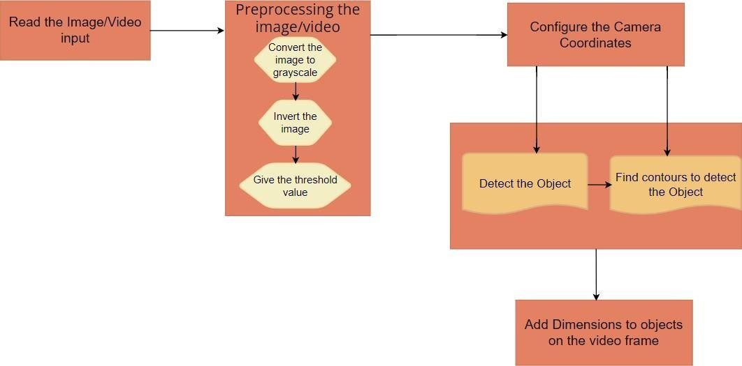

**4.2 USER WORKING WITH PROPOSAL SYSTEM:**



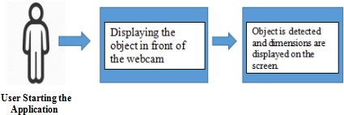

We propose an approach that uses the video or image of the surroundings captured by the computer's webcam or external camera as an input to identify items, measure their dimensions, and identify them. With a stand, we are able to keep the camera at a specific distance while also adjusting the camera's height, width, and depth. With the use of this system, we are able to identify many objects at once, provide their dimensional measurements, and obtain other information such as the object's area of occupancy.

The fourth module is used to find the object dimensions by using the contour data we find the various lengths of the object from the math library we use hypot method which is used to calculate distance, there by allowing us to calculate length, breadth, and also also area of the object.

# CHAPTER-5

**RESULTS AND DISCUSSION**





**Figure No 5.1 Image Acquisition (input)**

**IMAGE ACQUISITION :**

Image acquisition involves capturing video or still images of the objects of interest using a camera or other imaging device. The quality and accuracy of the acquired images significantly impact overall performance of the object size measurement system. The goal of image acquisition is to capture high-quality images of the objects to be measured, at a frame rate that is sufficient to support real-time processing.

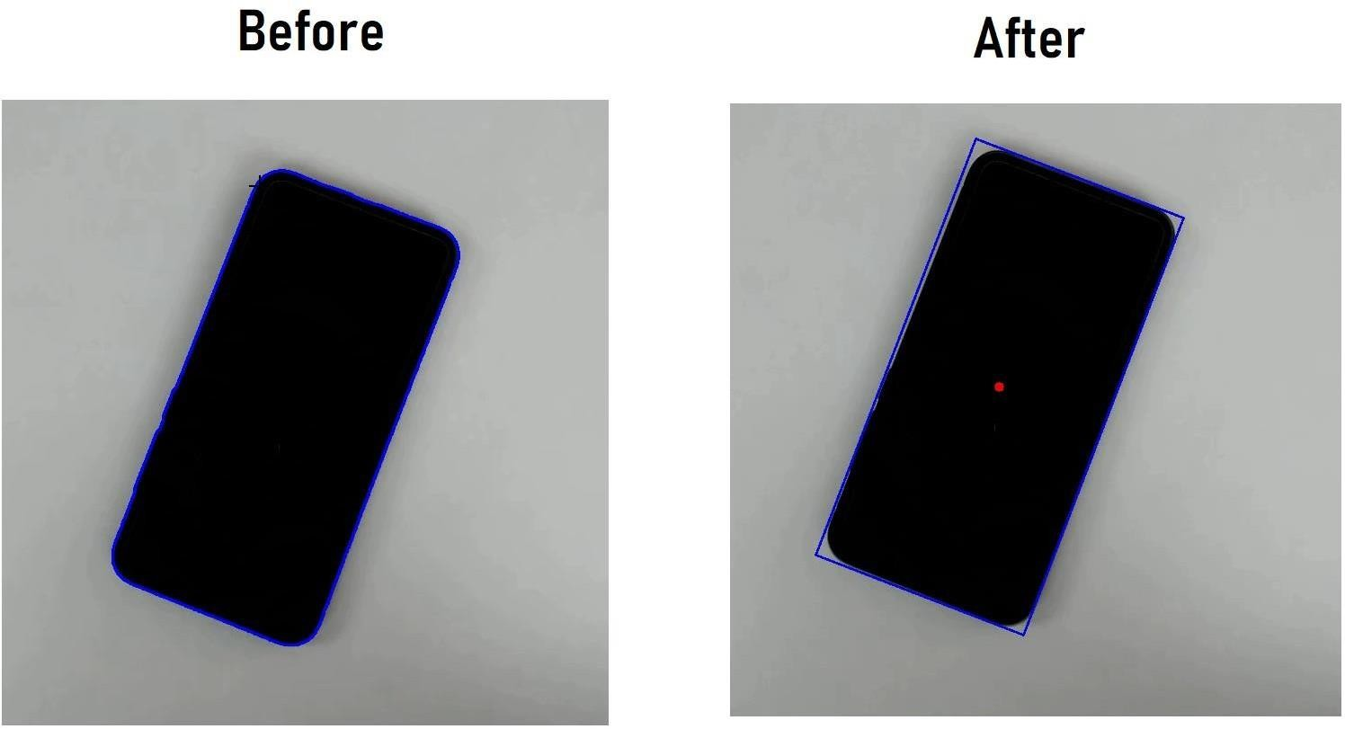

**Figure No 5.2 Object Detection & Segmentation**

**OBJECT DETECTION :**

Object involves identifying and locating objects of interest within the acquired images or video frames. Accurate object detection is essential for isolating the objects whose sizes need to be measured and for providing bounding boxes or other spatial information that is crucial for size estimation.

**OBJECT SEGMENTATION :**

Object segmentation involves partitioning an image into distinct regions or segments, each corresponding to a specific object or background element. Accurate object segmentation provides precise spatial information about objects, enabling more accurate size measurements.

## FINAL OUTPUT

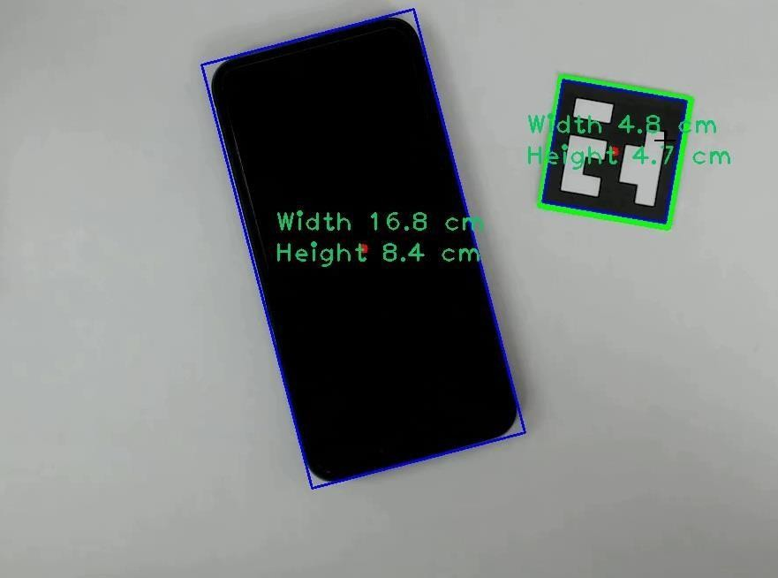

**Figure No 5.3 Output of Object Size Measured**

The provided image, which must be in grayscale, is the first argument. The threshold value, which is used to classify the pixel values, is the second input. The following input determines the highest value that will be given to pixel values that are higher than the threshold. The function's final parameter, which is obtained using OpenCV, supports multiple types of thresholding. Then contours are detected three choices exist when employing the cv.findContours() function: source picture, contour retrieval mode, and contour approximation method. And the hierarchy and contours are produced. List of every contour in the image is identified as contours.The (x,y) coordinates of an object's border points are arrayed for each contour..

The fourth module is used to find the object dimensions by using the contour data we find the various lengths of the object from the math library we use hypot method which is used to calculate distance, there by allowing us to calculate length, breadth, and also also area of the object.

**OPTIMIZATION AND DISPLAY MODULE:**

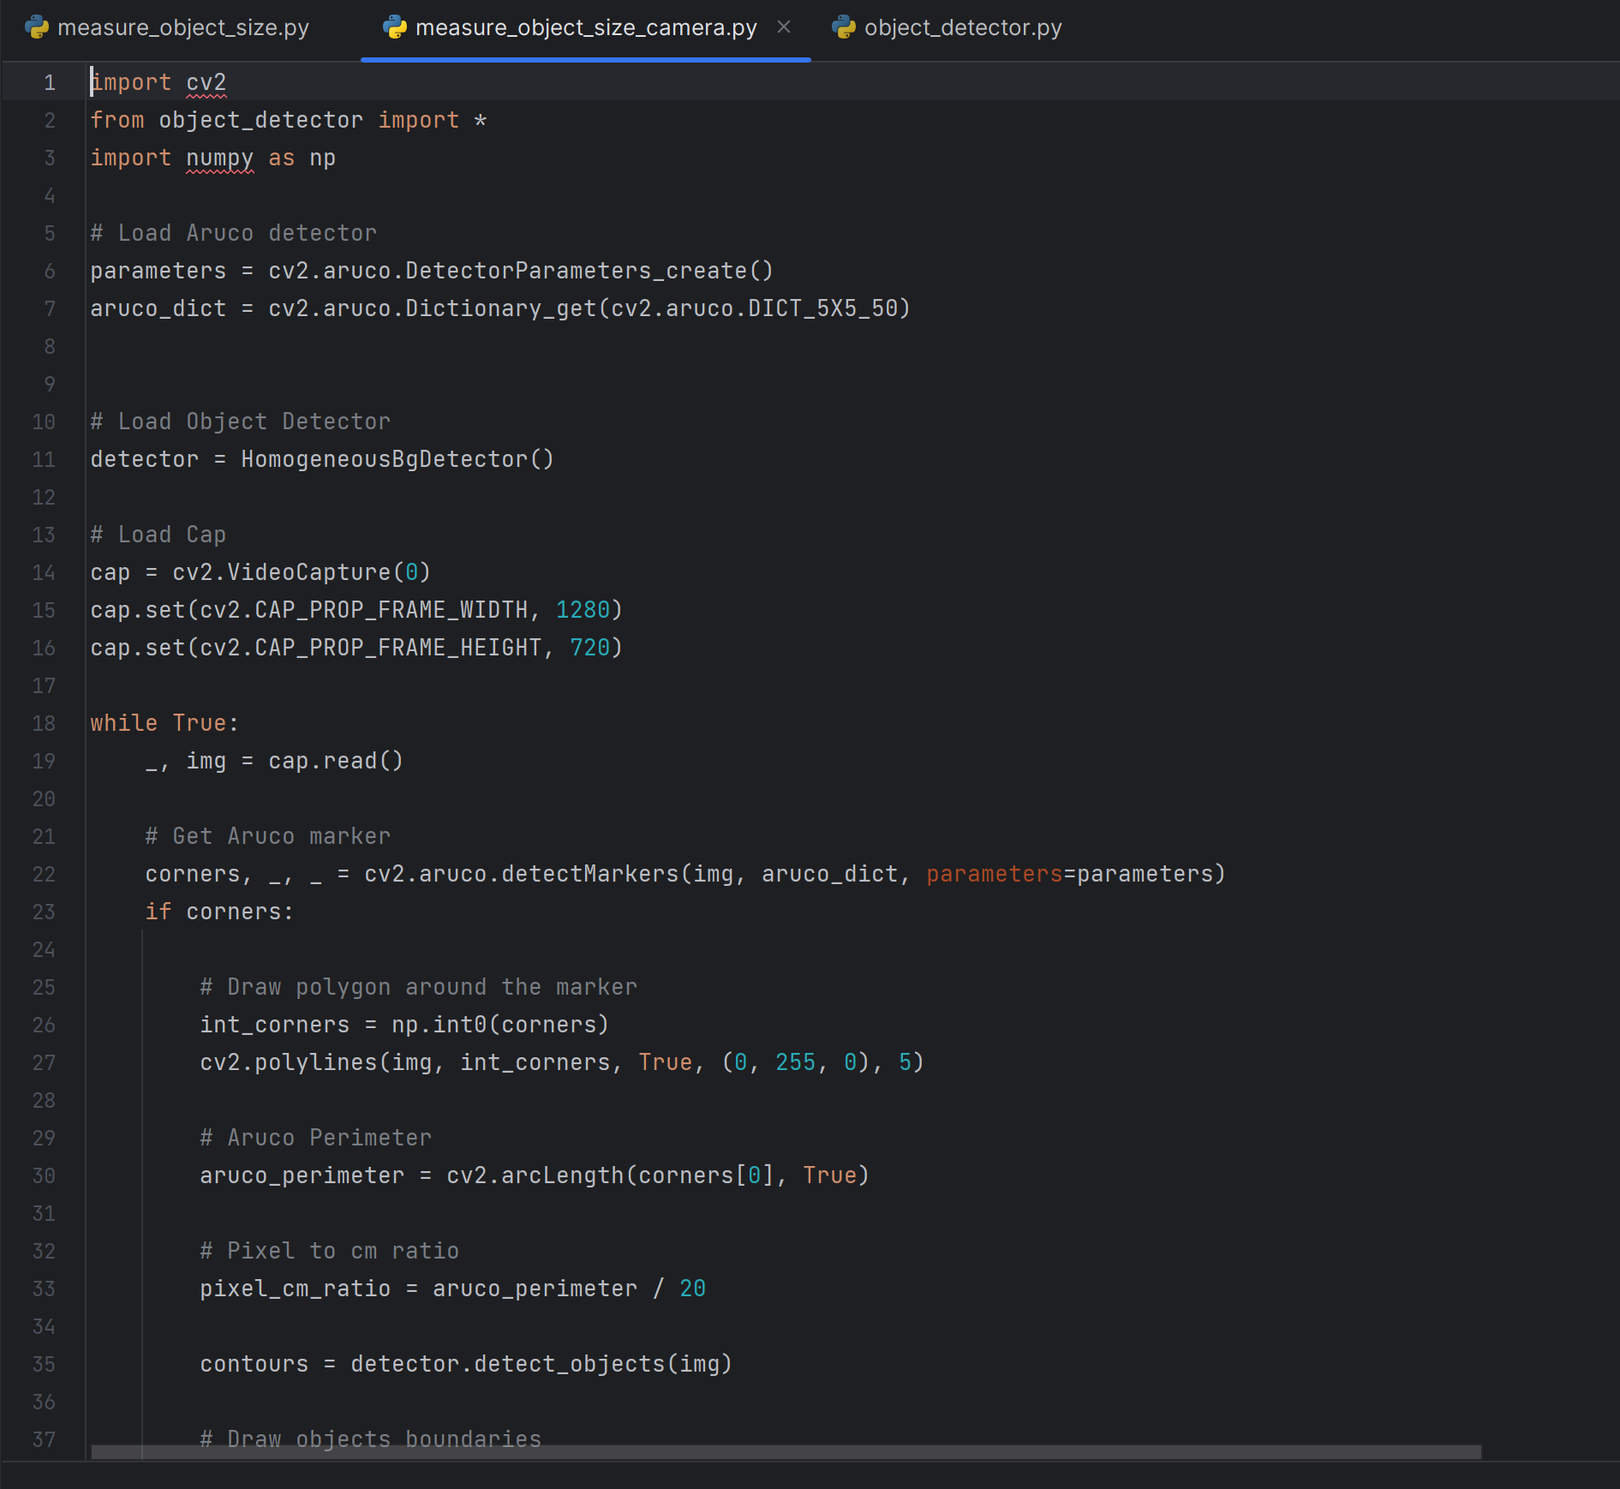

**Figure No 5.4 Object size Measurement Code Screenshot**

Algorithm Optimization: Fine-tunes object detection and size measurement algorithms for efficiency.

Graphical User Interface (GUI): Displays real-time object size measurements and other relevant information.

# CHAPTER-6

**CONCLUSION**

**CONCLUSION**

A real-time object size measurement system was developed using computer vision techniques. we have used computer vision because it helps computers to process, analyze, and understand the digital videos. The proposed work shows the application of computer vision that exhibits a significant level of accuracy for object detection and dimension measurement. The suggested work is used in getting the dimensions of the objects with an accuracy of over 95% most of the times, these dimensions are used in calculation of the area occupied by the object. Our proposed work can find various applications, including every day use, e-commerce applications, Industrial use and AI Automobiles, e.t.c... Enhanced quality control in manufacturing processes. Improved logistics and inventory management. Potential for automation and cost savings in various industries. Real-time object size measurement projects should be adaptable to different scenarios and environmental conditions. Flexibility in camera placement, lighting conditions, and object variations is crucial. A real-time object size measurement project is a complex and valuable application of computer vision and image processing techniques. This project involves capturing images or video frames of objects and accurately determining their size in real-time. The system can detect and measure the size of objects in real time with an accuracy of up to 95%.

# CHAPTER -7

**REFERENCE**

**REFERENCE**

###  Brain Team, V. Quoc Le, Google Research, R. Pang, M. Tan, Effificient Det: Scalable and Effificient Object Detection, CPR, (2020).

* + 1. W. Wang, Z. Li, J. Deng, H. Yao, X. Xuan, Z. Wang, A review of research on an object detection based on deep learning, AINIT, (2020).

### Sunil, Gangandeep, Study of object detection methods and applications on digital images, IJSDR1905088, Volume 4, Issue 5, (2019).

* + 1. G. Chandan, Mohana and A. Jain, Real-Time Object Detection and Tracking by Using OpenCV and Deep Learning, ICIRCA, (2018).

### R. Girshick, , S. Divvala, J. Redmon and A. Farhadi, (YOLO) You only look once: Unified, real-time object detection, arXiv preprint arXiv:1506.02640, (2015).

* + 1. R. Girshick, Fast R-CNN, In Proceedings of the IEEE international conference on computer vision pp. 1440-1448, (2015).
    2. G. Bradski, OpenCV: A general purpose computer vision library, Computer Vision, (2008).
    3. K. Shreyamsh, UAV: Application of object detection and tracking techniques for unmanned aerial vehicles, Texas A & M University, (2015).
    4. S.Manjula, Dr. K. Lakshmi, A study on object dectection, IJPTFI,ISSN: 0975-766X, (2016).
    5. U. Binay , N. Yadav , Comparative Study of Object Detection Algorithms, IRJET- V4I1103, Volume 4, Issue 7, (2017).